**OBJECT ORIENTED PROGRAMMING LAB**

**Name: Sanio Luke Sebastian**

**Roll No: 35**

**Batch: B**

**Date: 24-05-2022**

**Lab Cycle No.: 3**

**Aim**

1. Area of different shapes using overloaded functions.
2. Create a class ‘Employee’ with data members Empid, Name, Salary, Address and constructors to initialize the data members. Create another class ‘Teacher’ that inherit the properties of class employee and contain its own data members department, Subjects taught and constructors to initialize these data members and also include display function to display all the data members. Use array of objects to display details of N teachers.
3. Create a class ‘Person’ with data members Name, Gender, Address, Age and a constructor to initialize the data members and another class ‘Employee’ that inherits the properties of class Person and also contains its own data members like Empid, Company_name, Qualification, Salary and its own constructor. Create another class ‘Teacher’ that inherits the properties of class Employee and contains its own data members like Subject, Department, Teacherid and also contain constructors and methods to display the data members. Use array of objects to display details of N teachers.
4. Write a program has class Publisher, Book, Literature and Fiction. Read the information and print the details of books from either the category, using inheritance.
5. Create classes Student and Sports. Create another class Result inherited from Student and Sports. Display the academic and sports score of a student.
6. Create an interface having prototypes of functions area() and perimeter(). Create two classes Circle and Rectangle which implements the above interface. Create a menu driven program to find area and perimeter of objects.
7. Prepare bill with the given format using calculate method from interface.

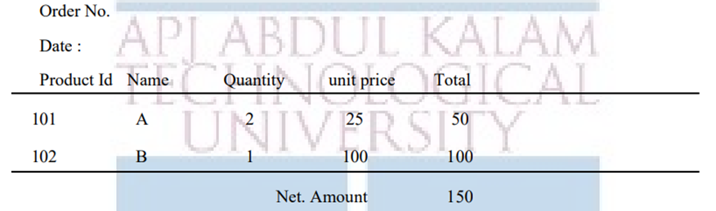

**Procedure & Outputs**

1. **ques01.java**

import java.util.*;

class ques01{

private void area(int side){

int area= side*side;

System.out.println("The area of square is "+area+"sqcm");

}

private void area(int length, int breadth){

int area= length*breadth;

System.out.println("The area of rectangle is "+area+"sqcm");

}

private void area(double length, double breadth){

double area= (length*breadth)/2;

System.out.println("The area of triangle is "+area+"sqcm");

}

private void area(double radius){

double area= 3.14*radius*radius;

System.out.println("The area of circle is "+area+"sqcm");

}

public static void main(String[] args){

Scanner sc= new Scanner(System.in);

int length1,breadth1,side;

double radius,length2,breadth2;

ques01 area= new ques01();

System.out.println("\nChoose the Operations to perform:\n1. Area of square.\n2. Area of rectangle.\n3. Area of triangle.\n4. Area of circle.\n");

int ch= sc.nextInt();

switch(ch){

case 1:{

System.out.println("\nEnter the value of side of the square: ");

side= sc.nextInt();

area.area(side);

break;

}

case 2:{

System.out.println("\nEnter the value of length of the rectangle: ");

length1= sc.nextInt();

System.out.println("\nEnter the value of breadth of the rectangle: ");

breadth1= sc.nextInt();

area.area(length1, breadth1);

break;

}

case 3:{

System.out.println("\nEnter the value of base of the triangle: ");

length2= sc.nextDouble();

System.out.println("\nEnter the value of height of the rectangle: ");

breadth2= sc.nextDouble();

area.area(length2, breadth2);

break;

}

case 4:{

System.out.println("\nEnter the value of radius of the circle: ");

radius= sc.nextDouble();

area.area(radius);

break;

}

}

sc.close();

}

}

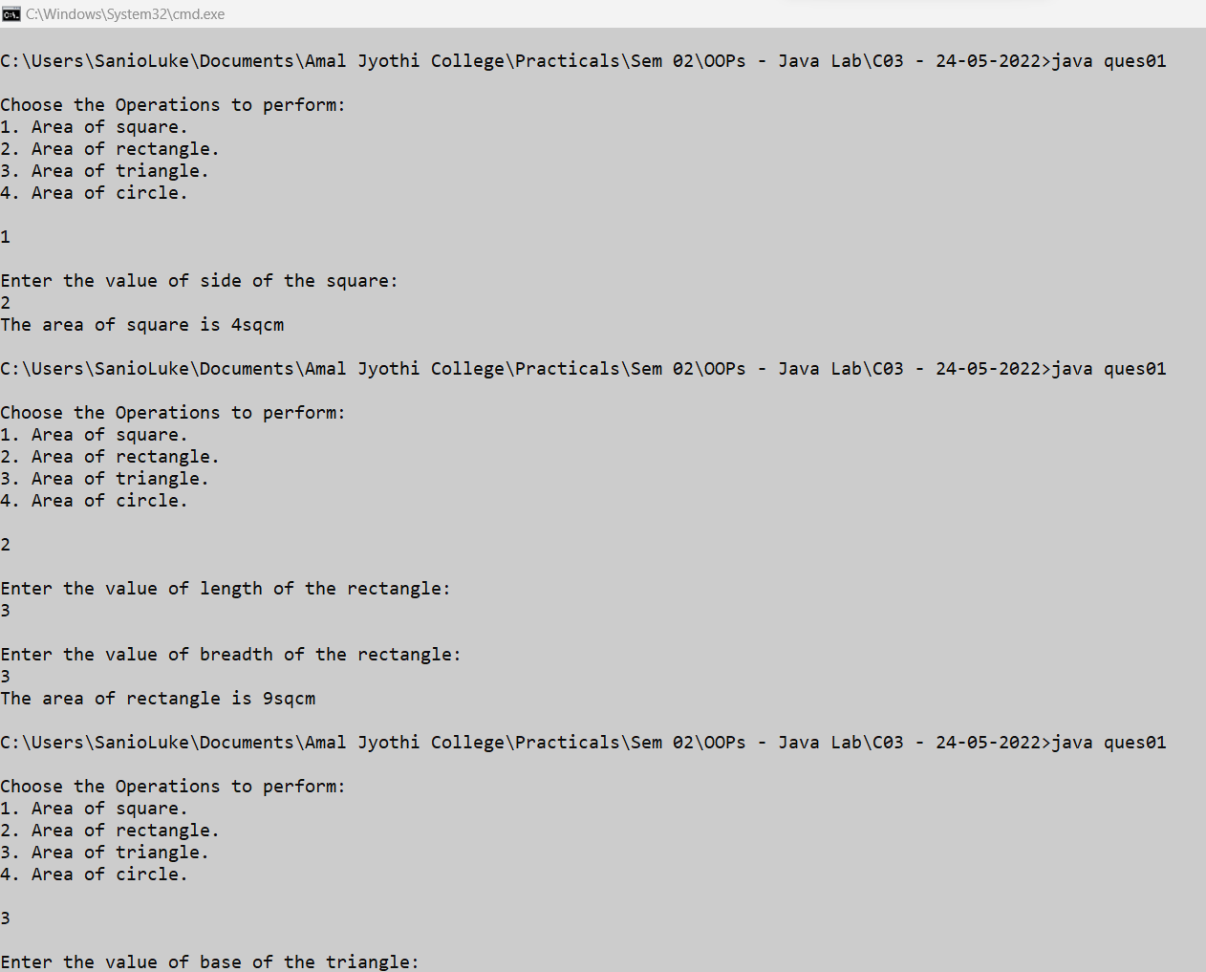

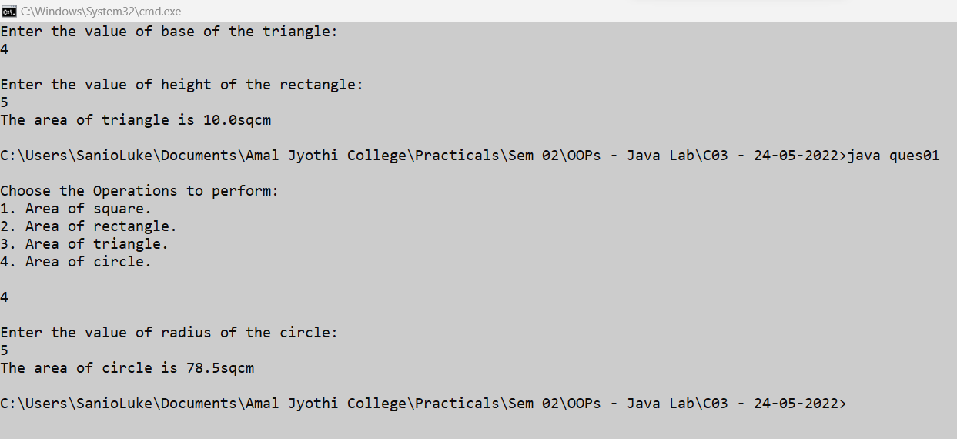

1. **ques02.java**

import java.util.Scanner;

class Employee {

int empid;

double salary;

String name, address;

Employee(int empid, String name, double salary, String address) {

this.empid = empid;

this.name = name;

this.salary = salary;

this.address = address;

}

}

class Teacher extends Employee {

String department, subjects;

Teacher(int empid, String name, double salary, String address, String department, String subjects) {

super(empid, name, salary, address);

this.department = department;

this.subjects = subjects;

}

void displayDetails(String emp) {

System.out.println("The ID of the " + emp + " is: " + this.empid);

System.out.println("The name of the " + emp + " is: " + this.name);

System.out.println("The salary of the " + emp + " is: " + this.salary);

System.out.println("The address of the " + emp + " is: " + this.address);

System.out.println("The department of the " + emp + " is: " + this.department);

System.out.println("The subjects of the " + emp + " is: " + this.subjects);

}

}

class ques02 {

public static void main(String[] args) {

int empnum;

Scanner sc = new Scanner(System.in);

System.out.print("Please enter the number of employees to entered : ");

empnum = sc.nextInt();

System.out.println("\n");

Teacher[] teachers_arr = new Teacher[empnum];

for (int i = 0; i < empnum; i++) {

int empid;

double salary;

String name, address;

String department, subjects;

System.out.print("Enter the empid of the " + (i + 1) + " teacher : ");

empid = sc.nextInt();

System.out.print("Enter the name of the " + (i + 1) + " teacher : ");

name = sc.next();

System.out.print("Enter the salary of the " + (i + 1) + " teacher : ");

salary = sc.nextDouble();

System.out.print("Enter the address of the " + (i + 1) + " teacher : ");

address = sc.next();

System.out.print("Enter the department of the " + (i + 1) + " teacher : ");

department = sc.next();

System.out.print("Enter the subjects of the " + (i + 1) + " teacher : ");

subjects = sc.next();

teachers_arr[i] = new Teacher(empid,name, salary, address, department, subjects);

System.out.println("\n");

}

for (int i = 0; i < teachers_arr.length; i++) {

String txt = (i == 0) ? (i + 1) + "st"

: ((i == 1) ? (i + 1) + "nd" : ((i == 2) ? (i + 1) + "rd" : (i + 1) + "th"));

teachers_arr[i].displayDetails(txt);

System.out.println("\n");

}

sc.close();

}

}

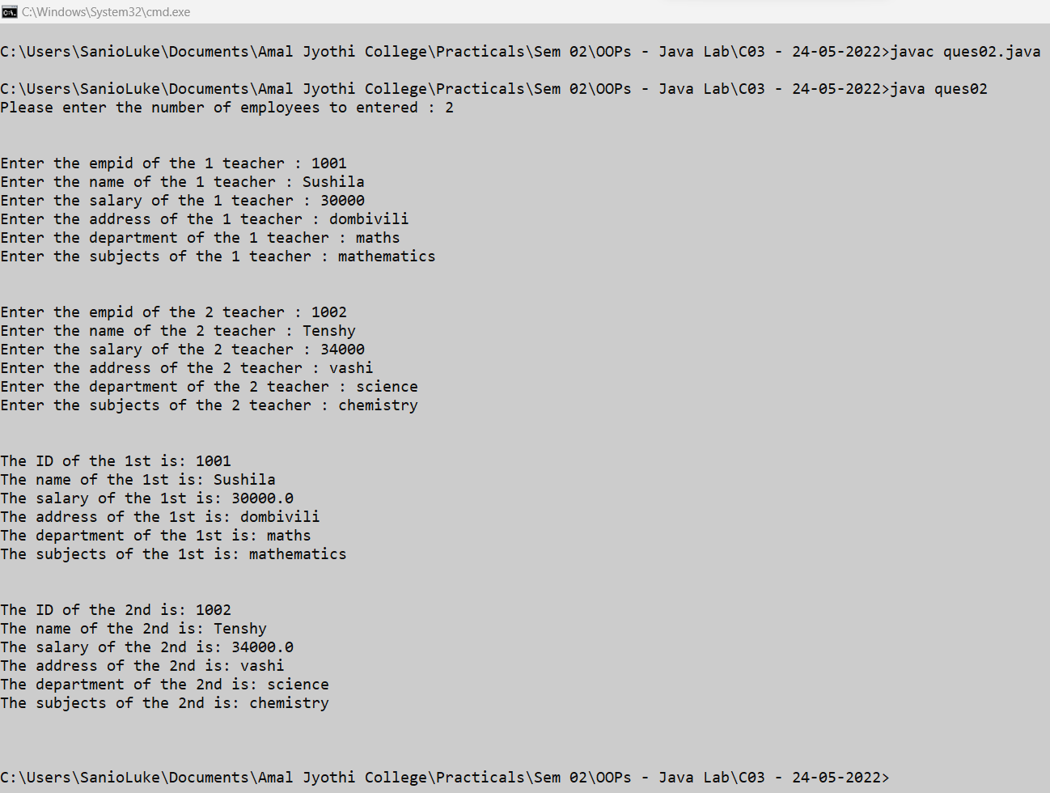

1. **ques03.java**

import java.util.Scanner;

class Person {

String name, gender, address;

int age;

public Person(String name, String gender, String address, int age) {

this.name = name;

this.gender = gender;

this.address = address;

this.age = age;

}

}

class Employee extends Person {

int empid;

double salary;

String company_name, qualification;

public Employee(String name, String gender, String address, int age, int empid, String company_name,

String qualification, double salary) {

super(name, gender, address, age);

this.empid = empid;

this.company_name = company_name;

this.qualification = qualification;

this.salary = salary;

}

}

class Teacher extends Employee {

int teacher_id;

String department, subject;

public Teacher(String name, String gender, String address, int age, int empid, String company_name,

String qualification, double salary, int teacher_id, String department, String subject) {

super(name, gender, address, age, empid, company_name, qualification, salary);

this.teacher_id = teacher_id;

this.department = department;

this.subject = subject;

}

void displayDetails(String emp) {

System.out.println("The name of the " + emp + " is: " + this.name);

System.out.println("The gender of the " + emp + " is: " + this.gender);

System.out.println("The address of the " + emp + " is: " + this.address);

System.out.println("The age of the " + emp + " is: " + this.age);

System.out.println("The employee ID of the " + emp + " is: " + this.empid);

System.out.println("The Company name of the " + emp + " is: " + this.company_name);

System.out.println("The qualification of the " + emp + " is: " + this.qualification);

System.out.println("The salary of the " + emp + " is: " + this.salary);

System.out.println("The teacher ID of the " + emp + " is: " + this.teacher_id);

System.out.println("The department of the " + emp + " is: " + this.department);

System.out.println("The subject of the " + emp + " is: " + this.subject);

}

}

class ques03 {

public static void main(String[] args) {

int empnum;

Scanner sc = new Scanner(System.in);

System.out.print("Please enter the number of teacher employees you want: ");

empnum = sc.nextInt();

System.out.println("\n");

Teacher[] teachers_arr = new Teacher[empnum];

for (int i = 0; i < empnum; i++) {

String name, gender, address, company_name, qualification, department, subject;

int age, empid, teacher_id;

double salary;

System.out.print("Enter the name of the " + (i + 1) + " teacher : ");

name = sc.next();

System.out.print("Enter the gender of the " + (i + 1) + " teacher : ");

gender = sc.next();

System.out.print("Enter the address of the " + (i + 1) + " teacher : ");

address = sc.next();

System.out.print("Enter the age of the " + (i + 1) + " teacher : ");

age = sc.nextInt();

System.out.print("Enter the emp ID of the " + (i + 1) + " teacher : ");

empid = sc.nextInt();

System.out.print("Enter the company name of the " + (i + 1) + " teacher : ");

company_name = sc.next();

System.out.print("Enter the qualification of the " + (i + 1) + " teacher : ");

qualification = sc.next();

System.out.print("Enter the salary of the " + (i + 1) + " teacher : ");

salary = sc.nextDouble();

System.out.print("Enter the teacher ID of the " + (i + 1) + " teacher : ");

teacher_id = sc.nextInt();

System.out.print("Enter the department of the " + (i + 1) + " teacher : ");

department = sc.next();

System.out.print("Enter the subject of the " + (i + 1) + " teacher : ");

subject = sc.next();

teachers_arr[i] = new Teacher(name, gender, address, age, empid, company_name,

qualification, salary, teacher_id, department, subject);

System.out.println("\n");

}

for (int i = 0; i < teachers_arr.length; i++) {

String txt = (i == 0) ? (i + 1) + "st"

: ((i == 1) ? (i + 1) + "nd" : ((i == 2) ? (i + 1) + "rd" : (i + 1) + "th"));

teachers_arr[i].displayDetails(txt);

System.out.println("\n");

}

sc.close();

}

}

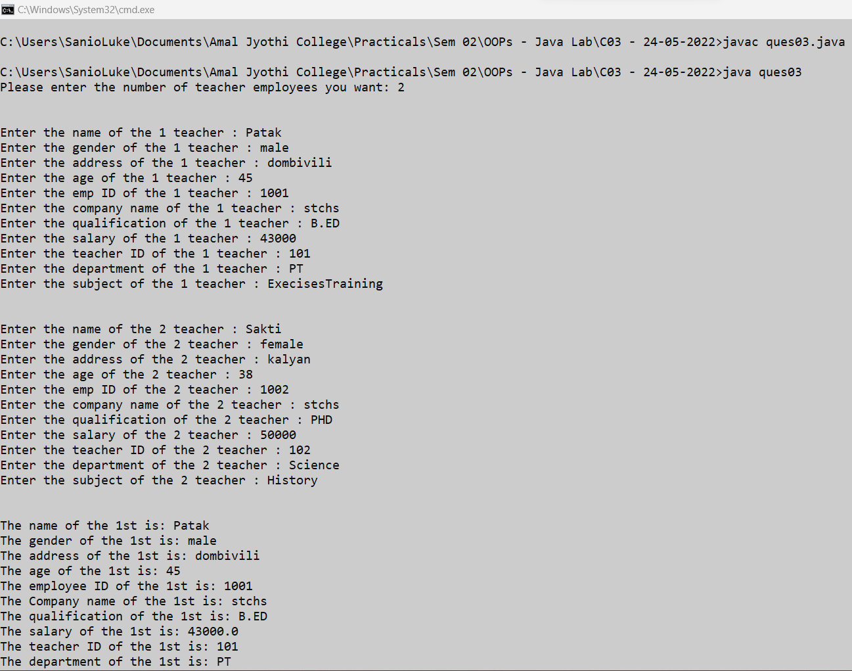

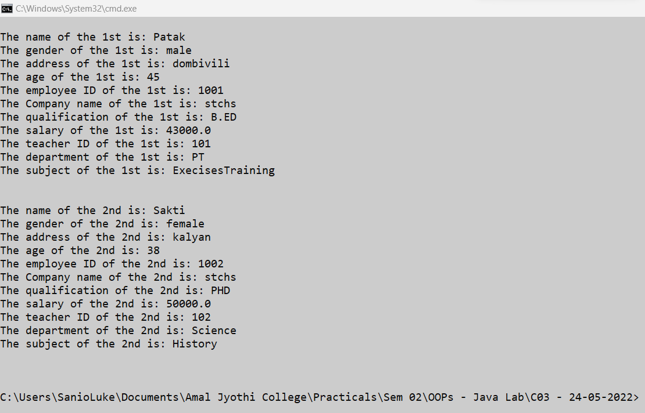

1. **ques04.java**

import java.util.Arrays;

import java.util.Scanner;

class Publisher {

int publisher_id;

String publisher_name;

Publisher(int publisher_id, String publisher_name) {

this.publisher_id = publisher_id;

this.publisher_name = publisher_name;

}

}

class Book extends Publisher {

int book_id;

String book_name;

Book(int publisher_id, String publisher_name, int book_id, String book_name) {

super(publisher_id, publisher_name);

this.book_id = book_id;

this.book_name = book_name;

}

}

class Literature extends Book {

int literature_id;

String literature_theme;

Literature(int publisher_id, String publisher_name, int book_id, String book_name, int literature_id,

String literature_theme) {

super(publisher_id, publisher_name, book_id, book_name);

this.literature_id = literature_id;

this.literature_theme = literature_theme;

}

void displayDetails() {

System.out.println("\n\nLiterature book details - ");

System.out.println("\nThe publisher ID of the book is: " + this.publisher_id);

System.out.println("The publisher name of the book is: " + this.publisher_name);

System.out.println("The Book ID of the book is: " + this.book_id);

System.out.println("The Book name of the book is: " + this.book_name);

System.out.println("The Literature ID of the book is: " + this.literature_id);

System.out.println("The Literature theme of the book is: " + this.literature_theme);

}

}

class Fiction extends Book {

int fiction_id;

String fiction_theme;

Fiction(int publisher_id, String publisher_name, int book_id, String book_name, int fiction_id,

String fiction_theme) {

super(publisher_id, publisher_name, book_id, book_name);

this.fiction_id = fiction_id;

this.fiction_theme = fiction_theme;

}

void displayDetails() {

System.out.println("\n\nFiction book details - ");

System.out.println("\nThe publisher ID of the book is: " + this.publisher_id);

System.out.println("The publisher name of the book is: " + this.publisher_name);

System.out.println("The Book ID of the book is: " + this.book_id);

System.out.println("The Book name of the book is: " + this.book_name);

System.out.println("The Fiction ID of the book is: " + this.fiction_id);

System.out.println("The Fiction theme of the book is: " + this.fiction_theme);

}

}

public class ques04 {

public static void main(String[] args) {

Scanner sc = new Scanner(System.in);

int n, type;

int publisher_id, book_id, literature_id, fiction_id;

String publisher_name, book_name, literature_theme, fiction_theme;

System.out.print("\nEnter the number of book items : ");

n = sc.nextInt();

Literature[] lit = new Literature[0];

Fiction[] fit = new Fiction[0];

for (int i = 0; i < n; i++) {

System.out.print("\nEnter the Publisher ID : ");

publisher_id = sc.nextInt();

System.out.print("Enter the Publisher Name : ");

publisher_name = sc.next();

System.out.print("Enter the Book ID : ");

book_id = sc.nextInt();

System.out.print("Enter the Book Name : ");

book_name = sc.next();

System.out.print("BOOK TYPE? 1. Literature 2. Fiction : ");

type = sc.nextInt();

if (type == 1) {

int item_no= lit.length;

lit= Arrays.copyOf(lit, lit.length + 1);

System.out.print("Enter the Literature ID : ");

literature_id = sc.nextInt();

System.out.print("Enter the Literature Name : ");

literature_theme = sc.next();

lit[item_no] = new Literature(publisher_id, publisher_name, book_id, book_name, literature_id, literature_theme);

} else {

int item_no= fit.length;

fit= Arrays.copyOf(fit, fit.length + 1);

System.out.print("Enter the Fiction ID : ");

fiction_id = sc.nextInt();

System.out.print("Enter the Fiction Name : ");

fiction_theme = sc.next();

fit[item_no] = new Fiction(publisher_id, publisher_name, book_id, book_name, fiction_id, fiction_theme);

}

}

if (lit.length > 0) {

for (int i = 0; i < lit.length; i++) {

lit[i].displayDetails();

}

}

if (fit.length > 0) {

for (int i = 0; i < fit.length; i++) {

fit[i].displayDetails();

}

}

sc.close();

}

}

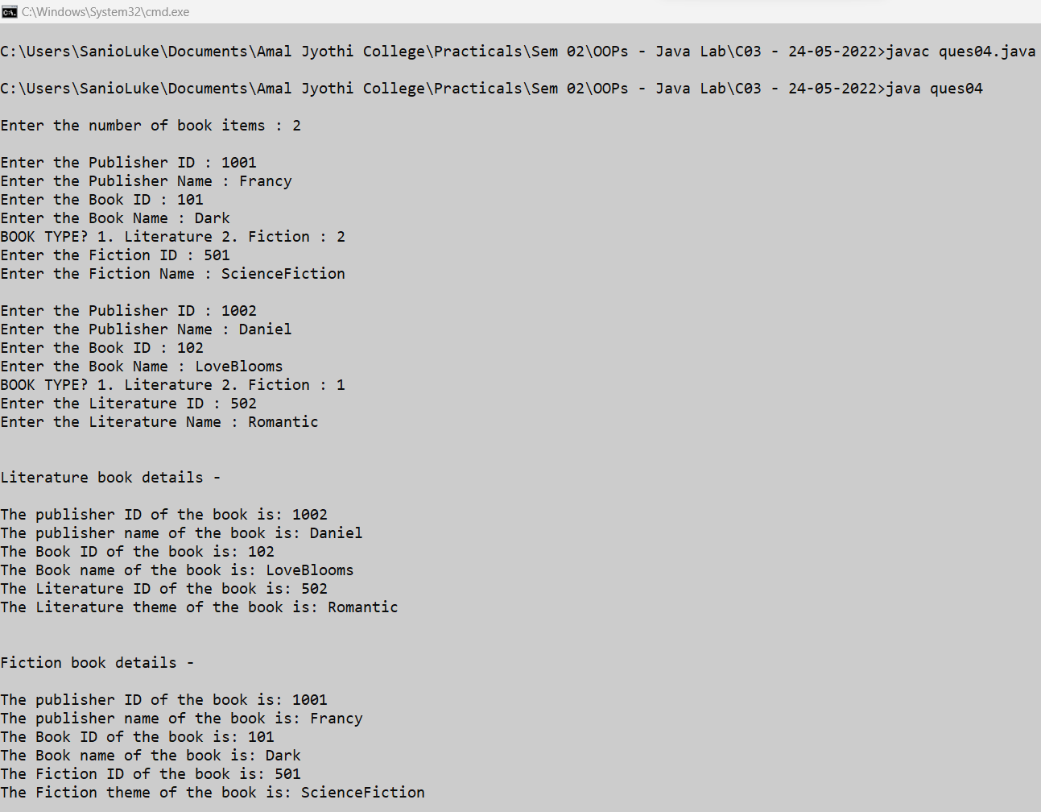

1. **ques05.java**

class Student {

int stud_id;

String stud_name, academic;

Student(int stud_id, String stud_name, String academic) {

this.stud_id = stud_id;

this.stud_name = stud_name;

this.academic= academic;

}

}

class Sports extends Student {

String sport_name;

int sports_score;

Sports(int stud_id, String stud_name, String academic, String sport_name) {

super(stud_id, stud_name, academic);

this.sport_name= sport_name;

}

}

class Result extends Sports{

int sports_score;

Result(int stud_id, String stud_name, String academic, String sport_name, int sports_score) {

super(stud_id, stud_name, academic, sport_name);

this.sports_score= sports_score;

}

}

public class ques05 {

public static void main(String[] args) {

Result result= new Result(1000, "Daniel Philip", "BSCIT", "Cricket", 100);

System.out.println("The academic of the student: "+result.stud_name+" is: " + result.academic);

System.out.println("The sports score of the student: "+result.stud_name+" is: " + result.sports_score);

}

}

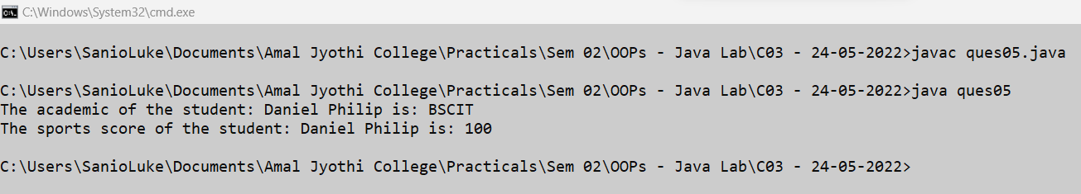

1. **ques06.java**

import java.util.*;

interface ShapeCalculate{

double area();

double perimeter();

}

class Circle implements ShapeCalculate{

int radius;

Circle(int radius){

this.radius= radius;

}

@Override

public double area() {

return (3.14*this.radius*this.radius);

}

@Override

public double perimeter() {

return (2*3.14*this.radius);

}

}

class Rectangle implements ShapeCalculate{

int length, breadth;

Rectangle(int length, int breadth){

this.length= length;

this.breadth= breadth;

}

@Override

public double area() {

return (this.length*this.breadth);

}

@Override

public double perimeter() {

return (2*(this.length+this.breadth));

}

}

public class ques06 {

public static void main(String[] args) {

Scanner sc= new Scanner(System.in);

int choice, isexit=0;

while(true){

System.out.println("\nMatheatical Operations: \n1. Area of a Rectangle.\n2. Perimeter of a Rectangle.\n3. Area of a circle.\n4. Perimeter of a circle.\n5. Exit\n");

System.out.print("Please enter the choice: ");

choice= sc.nextInt();

switch(choice){

case 1: {

int length, breadth;

System.out.print("\nEnter the length of the rectangle: ");

length= sc.nextInt();

System.out.print("Enter the length of the rectangle: ");

breadth= sc.nextInt();

ShapeCalculate rectangleshape= new Rectangle(length, breadth);

System.out.println("\nThe area of the mentioned rectangle is : "+rectangleshape.area()+"sqcm");

break;

}

case 2: {

int length, breadth;

System.out.print("\nEnter the length of the rectangle: ");

length= sc.nextInt();

System.out.print("Enter the length of the rectangle: ");

breadth= sc.nextInt();

ShapeCalculate rectangleshape= new Rectangle(length, breadth);

System.out.println("\nThe perimeter of the mentioned rectangle is : "+rectangleshape.perimeter()+"cm");

break;

}

case 3: {

int radius;

System.out.print("\nEnter the radius of the circle: ");

radius= sc.nextInt();

ShapeCalculate circleshape= new Circle(radius);

System.out.println("\nThe area of the mentioned rectangle is : "+circleshape.area()+"sqcm");

break;

}

case 4: {

int radius;

System.out.print("\nEnter the radius of the circle: ");

radius= sc.nextInt();

ShapeCalculate circleshape= new Circle(radius);

System.out.println("\nThe perimeter of the mentioned rectangle is : "+circleshape.perimeter()+"cm");

break;

}

case 5: {

isexit=1;

break;

}

}

if(isexit==1){

break;

}

}

}

}

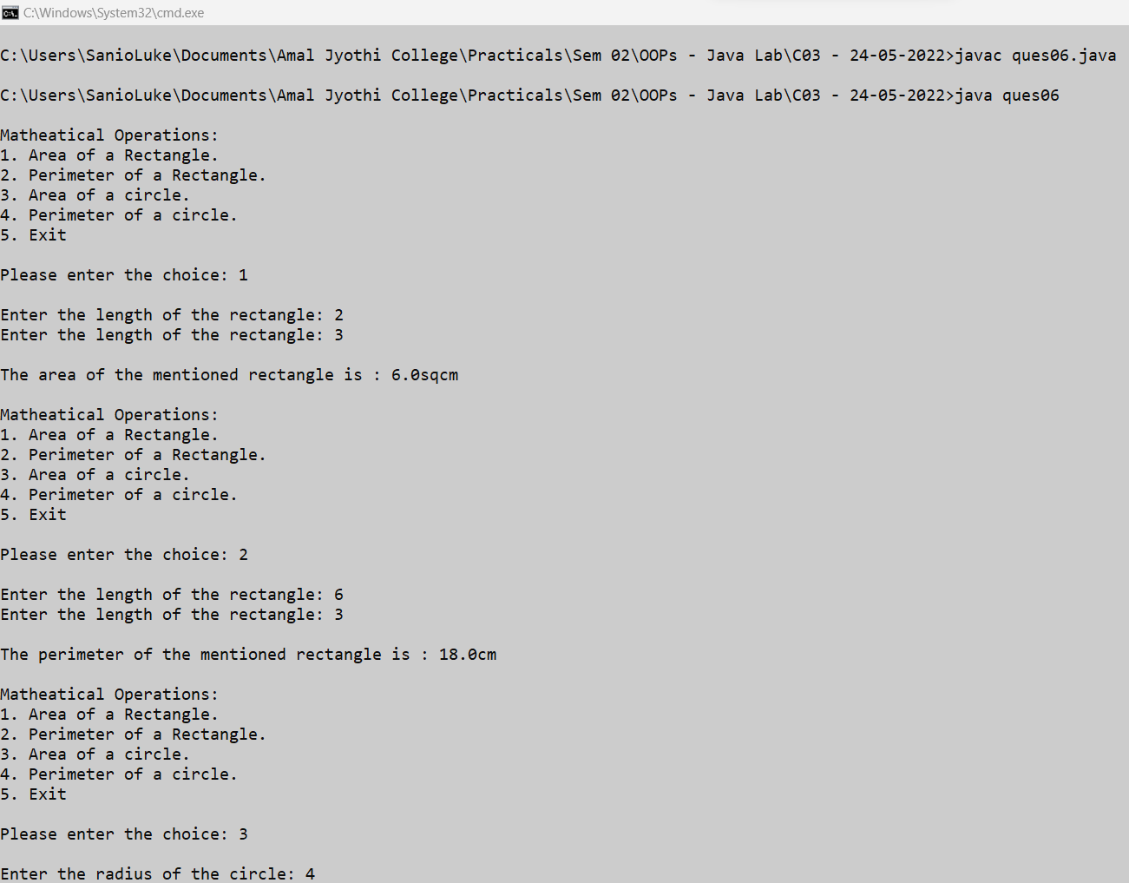

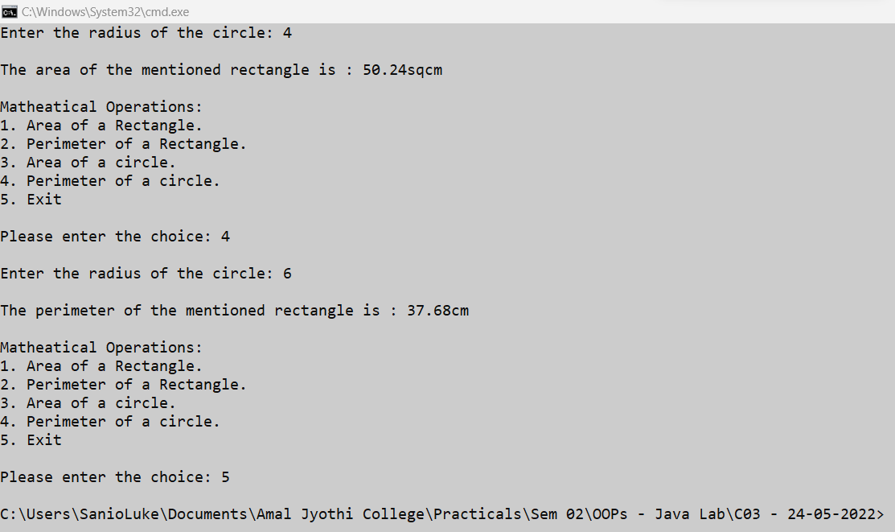

1. **ques07.java**

import java.util.Scanner;

interface calc{

void calculate();

}

class bill implements calc{

String date,name,p_id;

int quantity;

double unit_price,total,namount=0;

Scanner sc = new Scanner(System.in);

public void getdata(){

System.out.println("\nEnter product id:");

p_id = sc.nextLine();

System.out.println("Enter product name:");

name = sc.nextLine();

System.out.println("Enter the Quantity:");

quantity = sc.nextInt();

System.out.println("Enter the unit price:");

unit_price = sc.nextDouble();

}

public void calculate(){

total = quantity * unit_price;

}

public void display(){

System.out.println(p_id+"\t\t"+name+"\t\t"+quantity+"\t\t"+unit_price+"\t"+total);

}

}

public class ques07{

public static void main(String[] args) {

int n,i;

double namount=0,t;

int ran;

String date;

t = Math.random() *1000000;

ran = (int) t;

Scanner sc = new Scanner(System.in);

System.out.println("Order no. #"+ran);

System.out.print("Enter the date:");

date = sc.nextLine();

System.out.println("Enter how many products are there:");

n = sc.nextInt();

bill ob[] = new bill[n];

for(i=0;i<n;i++)

ob[i] = new bill();

for(i=0;i<n;i++){

ob[i].getdata();

ob[i].calculate();

}

System.out.println("Date:"+date);

System.out.println("Product Id Name Quantity unit price Total ");

System.out.println("--------------------------------------------------------------");

for(i=0;i<n;i++){

ob[i].display();

namount += ob[i].total;

}

System.out.println("--------------------------------------------------------------");

System.out.println("\t\t\t\tNet.Amount\t\t"+ namount);

sc.close();

}

}

